RESEARCH REPORT

ON

CONSUMER BEHAVIORS AND PERCEPTIONS OF FORTIFIED FOODS

MARCH 2005

CONSUMERS ASSOCIATION OF MALAWI
GLOBAL ALLIANCE FOR IMPROVED NUTRITION


TABLE OF CONTENTS
1 INTRODUCTION 4
1.1 Main Objective 5
1.2 Specific Objectives 5
2 DESCRIPTION OF THE PROBLEM 6
2.1 Background 6
2.2 Micronutrient Survey 6
2.3 Fortification in Malawi 7
3 METHODOLOGY 9
3.1 Target populations 9
3.2 Sampling 9
3.3 Data collection 10
4 RESULTS 11
4.1 Background characteristics of respondents 11
4.2 Access to mass media 11
4.3 Knowledge about Fortification 12
4.3.1 Level of Knowledge about fortification 13
4.3.2 Respondents Understanding of the Purpose of Fortification 14
4.4 Source of Information 15
4.5 Knowledge about Fortified Foods 15
4.6 Knowledge about Micronutrient Malnutrition 16
4.6.1 Level of knowledge about micronutrient malnutrition 17
4.7 Attitude towards importance of fortification 18
4.8 Attitude towards fortified foods 19
4.9 Respondents Current Behavior 20
4.9.1 Reasons for not buying fortified foods 20
4.9.2 Reasons for not prepared 22
5 DISCUSSION 23
5.1 Consumers’ Knowledge about micronutrient malnutrition 23
5.2 Consumers’ Knowledge about fortification 23
5.3 Consumer’s knowledge about fortified foods 24
5.3 Attitude towards fortification 24
5.4 Attitude towards choosing fortified foods 25
5.5 Behavior of consumers 25
5.4 Barriers to promotion of fortified foods 26
5.5 Best ways of communicating the concept of food fortification 26
6 RECOMMENDATIONS 27
APPENDIX 1: Acronyms and Abbreviations 28
APPENDIX 2: References 29

List of tables

Table 1 Background characteristics of respondents 11
Table 2: Access to mass media 12
Table 3: Knowledge about fortification 13
Table 4: Level of knowledge about fortification 14
Table 5: Understanding of the purpose of fortification 14
Table 6: Level of Knowledge about fortified foods 16
Table 7: Respondents current behavior 20
Table 8: Possible future behaviors 21

List of Figures

Figure 1: Respondents source of information about fortification 15
Figure 2: Proportion of respondents with knowledge about micronutrient malnutrition 17
Figure 3: Level of knowledge about micronutrient malnutrition 18
Figure 4: Attitude towards importance of fortification 19
Figure 5: Attitude towards choosing fortified foods on the market 19
Figure 6: Reasons for not buying fortified products (FP) 21
Figure 7: Reasons why respondents were not prepared to buy fortified foods in future 22

INTRODUCTION
The Consumers Association of Malawi (CAMA), a membership non-governmental organisation is a member of the National Fortification Alliance (NFA) and has a role in advocating on behalf of consumers, undertaking consumer education and awareness campaign. The Malawi government and the NFA to which CAMA belongs, will embark on a National Fortification Programme to promote fortifying commercially produced maize flour, vegetable oil and a local complimentary food called Likuni Phala. The goal of this programme is to make fortified food staples available, and affordable to most of the people in Malawi, thereby contribute to eleminating micronutrient deficiences.

It is conceived that such a goal can be achieved through building the capacity of industries, strengthening monitoring institutions and technical expertise. It is also conceived that the successful implementation of the fortication programme is an ongoing programme which requires creating demand by consumers to obtain and use the products properly. This demand is a key ingredient for the success and sustainability of the programme and needs to be increased through awareness campaigns.

CAMA received funding from the Global Alliance for Improved Nutrition (GAIN) to conduct a Consumer Marketing and Education of the fortified foods Programme. The overall goal is to create a sustainable consumer demand of fortified food among urban and rural consumers throughout the country through social marketing and communication.

The benefits of food fortification have to be aggressively marketed and there is need for an intensive consumer marketing and education campaign to create a perception of value in fortification, so that consumers accept the fortified products, see the need for paying a slightly higher price, and the importance of choosing fortified products over the competitors. Opinion leaders and authorities should be educated on the health benefits of consuming fortified foods for themselves, their children, the aged, and those affected by the HIV/AIDS pandemic. Mechanisms need to be put in place to help consumers identify the products on the market. This awareness is required to increase the willingness of consumers to change beliefs, habits so as to spend more money on fortified food. The first objective of the Consumer Marketing and Education Programme was to carry out a research study on consumer behaviours and perceptions of fortified foods and their impact on health.

Main Objective
To study consumer behaviours and perceptions of fortified foods and their impact on health

Specific Objectives
- To assess knowledge of consumers about fortification, micronutrient malnutrition and fortified foods that are currently available on the market
- To assess consumers attitude towards fortification and fortified foods
- To assess current and possible future behaviours of consumers towards fortified foods
- To identify barriers to the promotion of fortified foods
- To identify best ways of communicating the concept of fortification among urban and rural consumers

DESCRIPTION OF THE PROBLEM

Background
Malawi is one country in sub-Saharan Africa with a population of about 11.5 million as per figures of 2003. The country covers an area of 118, 000 square kilometres, a quarter of which is covered by Lake Malawi. Its population is spread in three regions of South, Central and North. 80% of the population resides in rural areas, and the remaining 20% is urban-based ^{4.}

Malawi’s economy is agro based with maize as the staple food. The basic income for 85% of the population depends heavily on rain-fed agriculture. The GDP per capita is US $ 182. At least 65% of the population lives below poverty line, earning less than US$ 1 per day. The literacy rate is 79 for males and 46 for females. Malawi has high under-five and maternal mortality rates estimated at 189 per 1, 000 live births and 1,120 per 100, 000 live births respectively according to the National Statistics Office data published on its website⁴.

Micronutrient Survey
The Ministry of Health with assistance from United Nations Children Fund (UNICEF) and Centres for Disease Control and Prevention (CDC) of Atlanta conducted a Malawi Micronutrient Survey (MMS) in 2001 in order to help the government of Malawi and the National Micronutrient Committee (NMC) to obtain a clear and better understanding of the national micronutrient situation that would then serve as a baseline from which to monitor the impact of specific interventions in the future².

The results of the survey showed that micronutrient deficiencies are a common public health problem in Malawi especially the deficiencies of Vitamin A, iodine, and iron which result in increased risk of serious illness, poor mental and physical development, anaemia, blindness, and death. The MMS demonstrated that micronutrient malnutrition is a serious problem in all target groups in Malawi, particularly among pre-school children and women of childbearing age. The primary cause of each of these deficiencies is low dietary intake of a specific micronutrient with diseases and parasitic infections playing a major role in contributing to micronutrient malnutrition. The survey also identified gaps in the interventions currently being implemented to control micronutrient deficiencies².

To overcome the problem, a national plan of action for the prevention and control of micronutrient malnutrition in Malawi was drawn for 2003- 2008. The prevention and control measures to address micronutrient malnutrition highlighted in the plan focus on vitamin A and iron supplementation; fortification of centrally processed flour, sugar, oil and salt; dietary diversification and modification; and public health measures³. Food fortification strategy has proved to be the most cost effective strategy in improving the micronutrient status of a large proportion of populations in developing countries⁵.

Fortification in Malawi
The Government decided to embark on a Malawi Food Fortification Programme (MFFP) in 1985 and for that purpose a National Fortification Alliance was set up in the same year. The MFFP started in 1985 with salt iodisation. In 1995, an Iodisation of Salt Act was passed by parliament which allows only iodised salt to be imported into Malawi and in 1998 subsidiary rules and regulations were formulated which encourages small-scale salt producers in the country to iodise their salt in complaince with the Act. There are a lot of weaknesses in monitoring and enforcement of the passed laws and regulations, which has led to reduction in the proportion of household consuming adequately iodized salt (37% according to the MMS, 2001). Also, some iodine is lost during inappropriate storage and poor selling and handling practices¹.

Following a Pellagra outbreak among Mozambican refugees who were in Malawi in early 1990s, the large-scale millers such as Rab Processors started fortifying maize flour. This fortification continued beyond the refugee, however the majority of the population do not benefit from this fortification programme since the majority of consumers live in rural areas and mill their maize at local mills¹.

Some companies and small-scale organisations are fortifying their products voluntarily. The Association of Likuni Phala, which includes units at mission hospitals such as St Gabriel's in Nathenje, St Annes in Mzuzu, Ekwendeni and Mulanje started fortifying Likuni Phala (Corn-Soya Blend) since 1997 with Iron, Calcium, Zinc, Vitamin A, Vitamin B1, Vitamin B2, Vitamin B12, Niacin amide, Folate and Vitamin C. World Food Programme (WFP) and Royal Dutch Institute funded the set up of these units. However, since 1998, they have been operating independently as an association. The Domasi Likuni Phala Production Unit (with funding from World Vision International (WVI) and Micronutrient and Health Project (MICAH)) in 1998 started producing fortified Likuni Phala and is now a part of the above association. Rab Processors Malawi Limited is also producing Likuni Phala and a part of their production is processed through tendering big orders for large international aid agencies. Likuni Phala producers are targeting under-five children and it is being marketed as both a complementary food and a breakfast cereal. Likuni Phala is also used as a food supplement for malnourished preschoolers, pregnant and lactating women and those with HIV/AIDS. However, the consumption of Likuni Phala is low throughout the country¹.

Unilever South East Africa is currently the only company that is voluntarily fortifying cooking oil and has been doing so since 1971. Fortification is with Vitamin A at the level of 30IU/g. The fortified oils cover 20% of the population and represents approximately 24% of the oils refined in Malawi. The fortification is still voluntary until such a time that the NFA finalises mandatory standards. The scenario in Malawi is encouraging in that the private sector took the initiative to begin fortifying their products and the effort they put into marketing their fortified products raises awareness of fortified foods and provides fortified food to the very remote poor households¹.

METHODOLOGY
This survey on consumer perception of fortification was conducted in early 2005 in six rural districts; Mulanje, Mwanza, Balaka, Dowa, Salima and Nkhatabay and in all the three cities of Malawi; Lilongwe, Blantyre and Mzuzu. It was conducted over a period of three months from February to April 2005.

Target populations
The targets were all consumers both in the rural and urban areas. In order to include both groups, the survey was conducted in two ways. Six districts were selected from the 29 administrative districts and all the three cities of Malawi were included in the survey. The sample selected from the six rural districts represented the rural Malawian consumers and sample selected from the cities represented the urban consumers in Malawi.

Sampling
In order to produce a national representative sample, random sampling was employed in all stages of the sampling process.

A two-stage cluster sampling design with stratification by district was employed in the six rural districts. In the first stage, two clusters (traditional authorities) were selected in a district and two villages were selected per cluster. The second sampling stage consisted of systematic equal probability sampling, with a random start; of households from each selected village. All households (a group of people who share a common cooking pot) in that village were included in the sampling frame and 45 selected. In the first household to be chosen the mother was interviewed and a father in the next household and a pupil in the third.

The survey, in the three cities, was conducted in work/ business places and residential areas. In each city a sampling frame of work/business places was prepared which included government departments, NGOs and companies from which six work places were randomly selected. Ten staff members representing various levels of employees were interviewed.

To include other urban residents who do not work, three residential areas were also randomly selected from a list of residential areas and forty households were selected per residential area using systematic random sampling with a random start. The head of the household (either a mother or a father) was selected from the first house and a pupil from the second house.

Data collection
Consumer Association of Malawi coordinated the fieldwork, which was conducted through CAMA District coordinators and auxiliary survey coordinators in some districts. Training of district and auxiliary survey coordinators on the overall survey objectives and procedures was conducted two weeks prior to data collection. Data was collected through the administration of questionnaires by the fieldworkers to the selected respondents.

RESULTS

Background characteristics of respondents
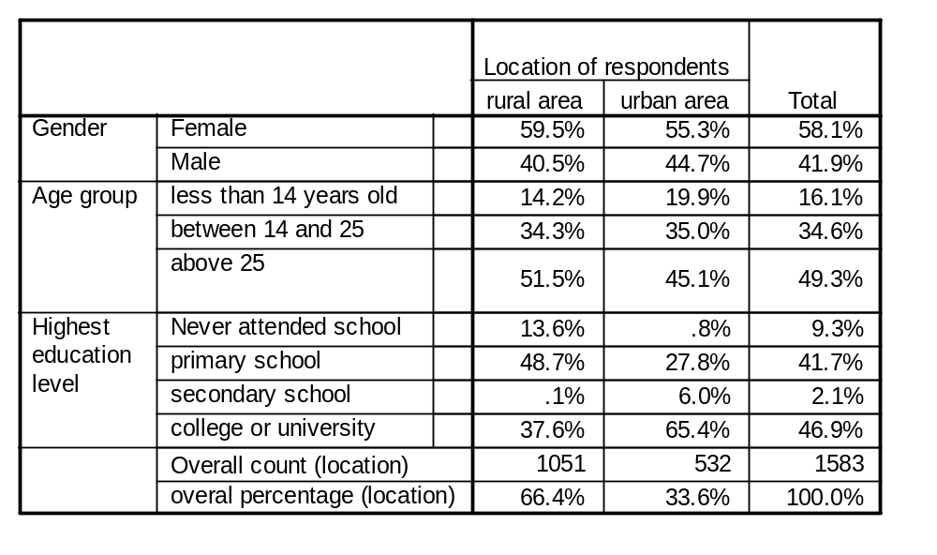
A total number of 1620 respondents were sampled from all the nine districts, 1080 from the six rural districts and 540 from the three cities. Out of these, 1051 from the rural districts and 532 from the cities participated in the survey giving response rates of 97.3% and 98.5% respectively. The overall response rate was 97.7%.
Table 1 Background characteristics of respondents

Access to mass media
As shown in table 2 below, the proportion of consumers who did not have access to all media was higher in the rural areas (11.0%) as compared to the urban areas (1.7%). 97.6% from the rural areas and 50.0% from the urban areas did not have access to Television Malawi. In the rural areas, 52.1% preferred listening to MBC radio 1, followed by 26.1% for MBC radio 2 while in the urban areas, 60.7% preferred listening to MBC radio 2 and 29.9% preferred MBC radio 1. Majority of respondents in the rural areas (93.1%) did not have access to newspapers while over half of the urban respondents (55.8%) did not have access to newspapers. The most preferred newspaper was The Nation with 15.8% and 2.3% of the urban and rural respondents respectively.

Table 2: Access to mass media
 |  | Rural area (%) | Urban area (%)
Access to all media | Completely no access to all media | 11.0 | 1.7
Access to all media | Had access to at least one media | 89.0 | 98.3
Access to Television Malawi | Had no access to TVM | 97.6 | 50.0
Access to Television Malawi | Had access to TVM | 2.4 | 50.0
Preferred radio station | Had no radio | 11.0 | 1.7
Preferred radio station | MBC Radio 1 | 52.1 | 29.9
Preferred radio station | MBC Radio 2 | 26.1 | 60.7
Preferred radio station | Capital FM | .5 | 3.9
Preferred radio station | Power 101 FM | 6.9 | .9
Preferred radio station | Joy radio | 1.0 | .2
Preferred radio station | MIJ Radio | 1.4 | .2
Preferred radio station | Other radios | .9 | 2.4
Preferred Newspaper | Had no access to newspapers | 93.1 | 55.8
Preferred Newspaper | Daily times | .9 | 11.1
Preferred Newspaper | The Nation | 2.8 | 15.8
Preferred Newspaper | Malawi news | .8 | 10.3
Preferred Newspaper | Weekend nation | 1.1 | 7.0
Preferred Newspaper | Other papers | 1.3 | 0.0

Knowledge about Fortification
Respondents were asked if they had ever heard or if they had knowledge about fortification (see table 3). Over half (56.7%) of the respondents in the rural areas and 41.9% of respondents in the urban areas had no knowledge about fortification. Higher proportions of respondents that were “less than 14 years old”, in both rural (70.8%) and urban (65.8%) areas, had no knowledge about fortification. Also, 84.6% of respondents who had never attended school in the rural areas had no knowledge about fortification as compared to 50.0% in the urban area.

Table 3: Knowledge about fortification

Characteristics of respondents | No knowledge about fortification |  | Had knowledge about fortification
 | Rural % | Urban % | Rural % | Urban %
Overall | 56.7 | 41.9 | 43.3 | 58.1
Age
Less than 14 years old | 65.8 | 70.8 | 34.2 | 29.2
Between 14 and 25 | 49.3 | 42.5 | 50.7 | 57.5
Above 25 | 59.1 | 28.8 | 40.9 | 71.3
Gender
Female | 57.8 | 45.6 | 42.2 | 54.4
Male | 55.2 | 37.4 | 44.8 | 62.6
Education level
Never attended school | 84.6 | 50.0 | 15.4 | 50.0
Primary school | 59.4 | 58.1 | 40.6 | 41.9
Secondary school | 43.3 | 37.6 | 56.7 | 62.4
College or university | 0.0 | 12.5 | 100.0 | 87.5

Level of Knowledge about fortification
Out of the respondents who had knowledge about fortification, only 20.1% (urban areas) and 18.7% (rural areas) had high knowledge about fortification (these respondents explained fortification as a way/ process of adding vitamins and/or minerals to food in order to increase the level of micronutrients contained in the food) (see table 4). All those that were close to the above explanation but failed to explain in detail what fortification is all about were categorized as having low knowledge. Only, less than 10% of both urban and rural respondents that were “less than 14 years old” had high knowledge about fortification. In the urban area, more men (26.2%) than women (14.4%) had high knowledge about fortification.

Table 4: Level of knowledge about fortification
Characteristics of respondents | High knowledge |  | Low knowledge
 | Rural (%) | Urban (%) | Rural (%) | Urban (%)
Overall | 18.7 | 20.1 | 81.3 | 79.9
Age
Less than 14 years old | 9.8 | 9.7 | 90.2 | 90.3
Between 14 and 25 | 19.7 | 22.4 | 80.3 | 77.6
Above 25 | 19.9 | 20.5 | 80.1 | 79.5
Gender
Female | 17.8 | 14.4 | 82.2 | 85.6
Male | 19.9 | 26.2 | 80.1 | 73.8
Education level
Never attended school | 4.5 | 100.0 | 95.5 | 0.0
Primary school | 18.8 | 14.5 | 81.3 | 85.5
Secondary school | 20.1 | 19.8 | 79.9 | 80.2
College or university | 0.0 | 28.6 | 100.0 | 71.4

Respondents Understanding of the Purpose of Fortification
As shown in table 5 below, only 7.8% and 12.6% of the rural and urban respondents respectively knew the main purpose of fortification, which is “improving health status through increased micronutrient intake”. Over 30% of rural respondents and over 40% of urban respondents understood fortification just as a way of improving quality of products.
Table 5: Understanding of the purpose of fortification
Characteristics of respondents | Didn’t know fortification |  | Knew fortification but didn’t know its purpose |  | Improving health through increased micronutrient intake |  | Improving product quality
 | Rural (%) | Urban (%) | Rural (%) | Urban (%) | Rural (%) | Urban (%) | Rural (%) | Urban (%)
Overall | 56.7 | 41.9 | 3.1 | 0.6 | 7.8 | 12.6 | 32.4 | 44.9

Age
Less than 14 years old | 65.8 | 70.8 | 4.0 | 0.0 | 4.0 | 1.9 | 26.2 | 27.4
Between 14 and 25 | 49.3 | 42.5 | 3.6 | 0.5 | 8.6 | 11.8 | 38.5 | 45.2
Above 25 | 59.1 | 28.8 | 2.6 | 0.8 | 8.3 | 17.9 | 29.9 | 52.5

Gender
Female | 57.8 | 45.6 | 3.5 | 1.0 | 7.5 | 10.2 | 31.2 | 43.2
Male | 55.2 | 37.4 | 2.6 | 0.0 | 8.2 | 15.5 | 34.0 | 47.1

Education Level
Never attended school | 84.6 | 50.0 | 0.7 | 0.0 | 2.8 | 0.0 | 11.9 | 50.0
Primary school | 59.4 | 58.1 | 4.5 | 0.0 | 6.1 | 4.7 | 30.1 | 37.2
Secondary school | 43.3 | 37.6 | 2.3 | 0.6 | 11.9 | 14.1 | 42.5 | 47.7
College or university | 0.0 | 12.5 | 0.0 | 3.1 | 0.0 | 34.4 | 100.0 | 50.0

Source of Information
As shown in figure 1 below, 55.0% of urban respondents reported to have heard about fortification from the radio followed by 13.3% from Television, 11% at school and 7.8% read in newspapers. In rural areas, 48.1% reported to have heard about fortification from the radio followed by hospitals (23.3%), school (12.5%) and community awareness meetings (8.3%).

Figure 1: Respondents source of information about fortification
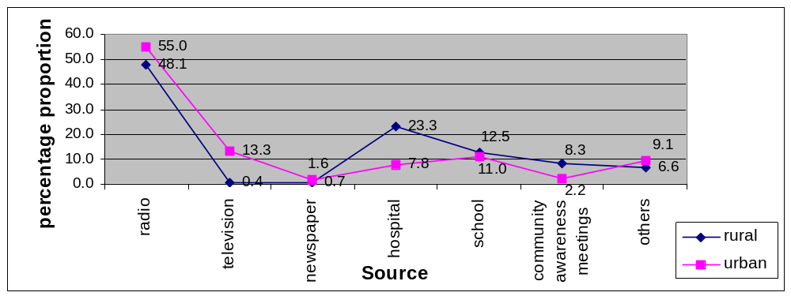

Knowledge about Fortified Foods
Respondents were also asked if they knew any fortified product currently available on the market. According to the results shown in Table 6 below, the proportion of respondents with no knowledge of any one fortified food available on the market was high in both areas especially in the rural areas (42.2%) than in the urban areas (34.0%). Higher proportions of respondents who had never attended school had no knowledge about fortified food (88.1%-rural and 75.0%- urban). The proportion of respondents with no knowledge about fortified foods was decreasing with increase in the education level attained. Only 11.4%-rural and 23.3%-urban had high knowledge about fortified foods. And almost 100% of respondents who had high or low knowledge of fortified foods currently available on the market mentioned iodised salt and iodine as one example.
Table 6: Level of Knowledge about fortified foods
Characteristics of respondents | No Knowledge* |  | Low Knowledge** |  | High Knowledge***
Characteristics of respondents | Rural % | Urban % | Rural % | Urban % | Rural % | Urban %
Overall | 42.2 | 34.0 | 46.4 | 42.7 | 11.4 | 23.3
Age
Less than 14 years old | 49.3 | 47.3 | 39.3 | 46.1 | 11.4 | 6.6
Between 14 and 25 | 39.3 | 33.3 | 43.0 | 43 | 17.7 | 23.7
Above 25 | 47.5 | 31.3 | 37.0 | 33.7 | 15.5 | 35
Gender of participant
Female | 44.0 | 37.4 | 45.8 | 41.2 | 10.2 | 21.4
Male | 40.0 | 31.0 | 46.9 | 43.4 | 13.1 | 25.6
Education level of participant
Never attended school | 68.2 | 60.8 | 29.0 | 39.2 | 2.8 | 0.0
Primary school | 48.2 | 50.7 | 41.4 | 37.8 | 10.4 | 11.5
Secondary school | 42.7 | 31.4 | 41.4 | 42.7 | 15.9 | 25.9
College or university | 0.o | 0.0 | 100 | 46.9 | 0.0 | 53.1
Note: *Did not know any fortified product currently available on the market
**Knew at least two fortified products
***Knew more that three fortified products

Knowledge about Micronutrient Malnutrition
Figure 2 below shows the proportion of respondents who had knowledge about the problem of micronutrient malnutrition in Malawi. The proportion was approximately the same in both rural and urban areas. 64.4% and 64.8% in rural and urban areas respectively knew about the problem of micronutrient malnutrition in Malawi. More youths (69.9%-rural and 76.2%-urban) and adults (75.4%-rural and 61.2%-urban), of the “between 14 and 25” and “above 25” age groups respectively, knew about the problem of micronutrient malnutrition than respondents of the “less than 14 years” age group (32.1%-rural and 47.7%-urban).

Figure 2: Proportion of respondents with knowledge about micronutrient malnutrition
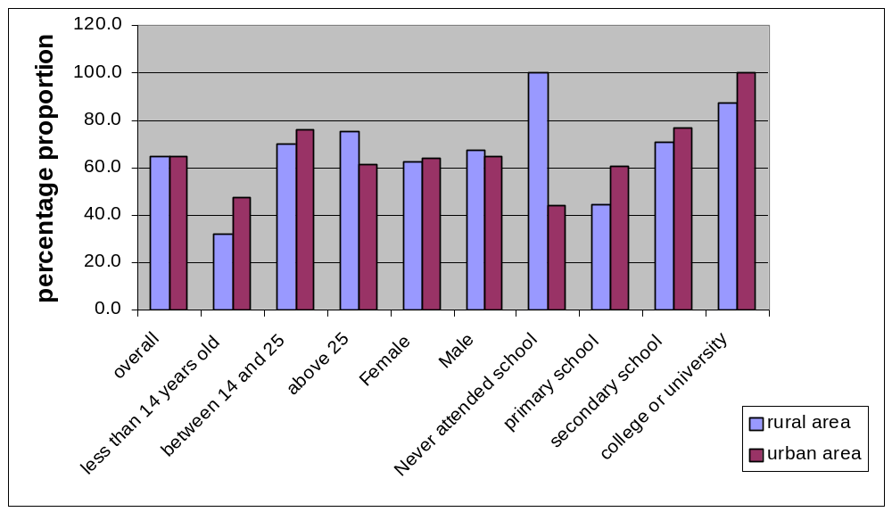

Level of knowledge about micronutrient malnutrition

Figure 3 below shows the level of knowledge of the respondents about the problem of micronutrient malnutrition in Malawi. Higher proportions of both rural (83.9%) and urban (79.4%) respondents had low knowledge about micronutrient malnutrition. They mentioned less than two examples of symptoms of micronutrient deficiencies. Those with high knowledge mention at least three examples and the causative micronutrient.

Figure 3: Level of knowledge about micronutrient malnutrition
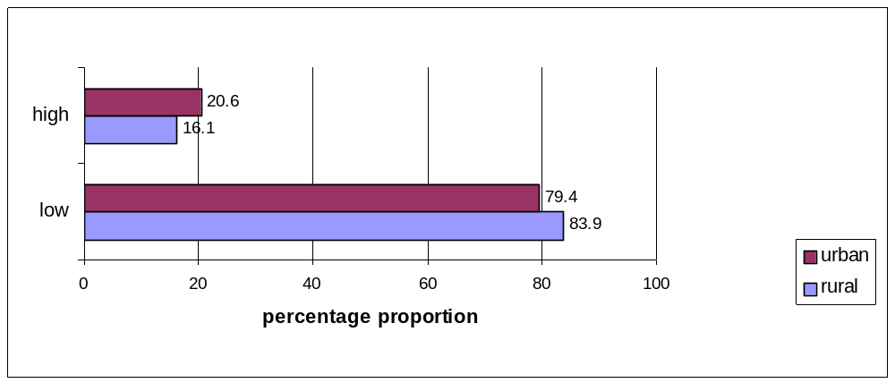

Attitude towards importance of fortification

Attitude towards the importance of fortification, to the elimination of micronutrient malnutrition, was assessed among respondents who had knowledge about the problem of micronutrient malnutrition in Malawi (see figure 4 below). Only 12.6% (rural) and 7.0% (urban) felt that fortification was not important and could not eliminate micronutrient malnutrition. 11.8% (rural) and 17.7% (urban) felt that fortification was not very important because it could not benefit the poor Malawian community. The majority of urban (75.4%) and rural (75.6) respondents felt that fortification was important and could eliminate micronutrient malnutrition.

Figure 4: Attitude towards importance of fortification
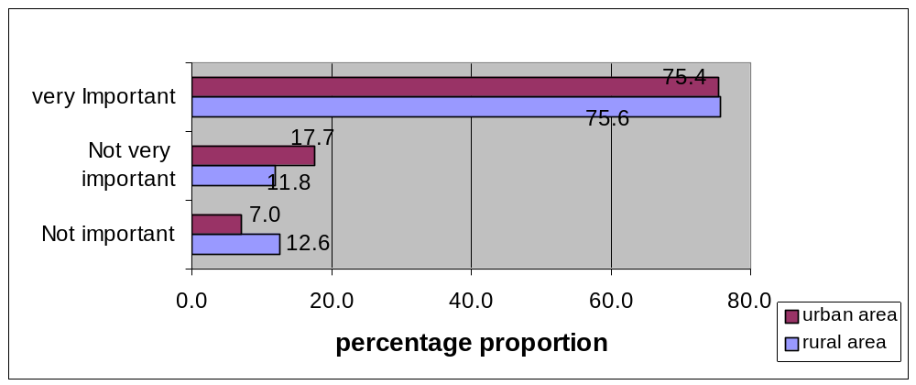

Attitude towards fortified foods
Basing on what the consumer would prefer to buy on the market, approximately 90% of the respondents in both rural and urban areas had positive attitude towards choosing fortified foods on the market instead of their non-fortified substitutes (Figure 5). Only 10.2% and 9.9% of respondents in rural and urban areas respectively reported that they would go for non-fortified products while less than .5% of both urban and rural respondents reported that they would go for any product.
Figure 5: Attitude towards choosing fortified foods on the market
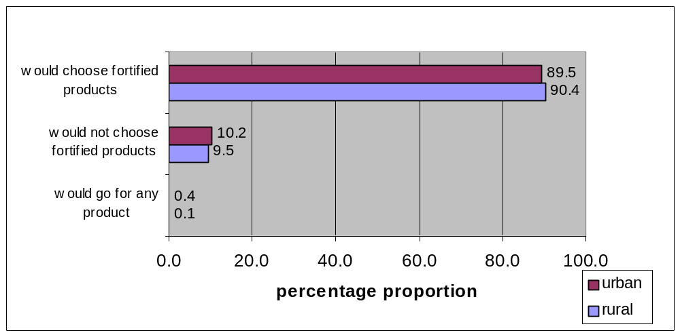

Respondents Current Behavior
A list of fortified foods currently available on the market was prepared and respondents were asked if they buy them in their homes in order to assess consumers’ current behaviour towards fortified foods. As shown in (table 7) 19.7% (urban) and 32.6% (rural) did not buy any one fortified food while approximately 1 in every 10 (urban areas) and 2 in every 10 (rural areas) bought fortified foods irregularly.
Table 7: Respondents current behavior
 | Do not buy fortified products |  | Buy fortified products irregularly |  | Always buy fortified products
 | Rural % | Urban % | Rural % | Urban % | Rural % | Urban %
Overall | 32.6 | 19.7 | 2.3 | 0.9 | 65.1 | 79.3
Age
Less than 14 years old | 24.8 | 31.1 | 0.0 | 0.0 | 75.2 | 68.9
Between 14 and 25 | 27.1 | 18.3 | 1.9 | 1.1 | 70.9 | 80.6
Above 25 | 38.4 | 15.8 | 3.1 | 1.3 | 58.4 | 82.9
Gender
Female | 37.0 | 20.7 | 2.1 | 1.0 | 61.0 | 78.2
Male | 26.3 | 18.5 | 2.6 | 0.8 | 71.1 | 80.7
Education level
Never attended school | 49.7 | 32.3 | 9.1 | 7.4 | 41.3 | 60.3
Primary school | 36.3 | 28.4 | 1.2 | 1.4 | 62.5 | 70.3
Secondary school | 21.5 | 17.2 | 1.3 | 0.9 | 77.2 | 81.9
College or university | 0.0 | 0.0 | 0.0 | 9.4 | 100.0 | 90.6

Reasons for not buying fortified foods
Approximately 90% of both urban and rural respondents didn’t buy and/or buy irregularly because fortified foods were expensive (figure 6).

Figure 6: Reasons for not buying fortified products (FP)
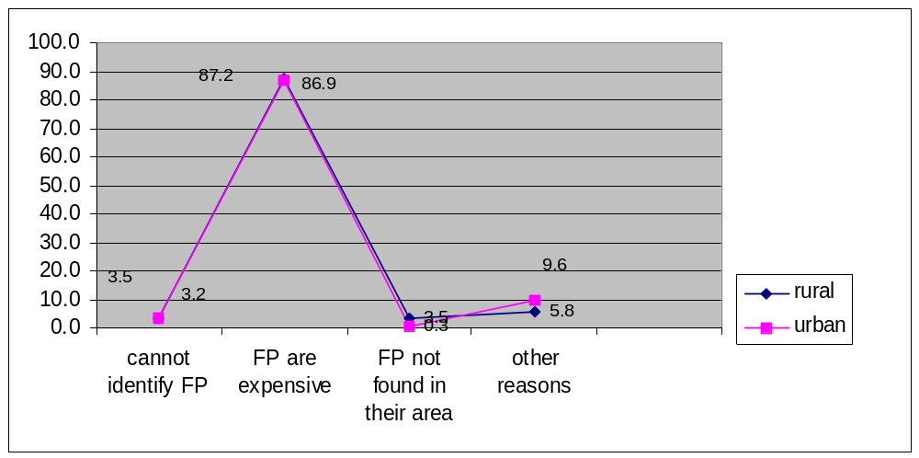
4.10 Possible future behaviours
Basing on whether respondents were prepared to buy fortified food staples in future so that they benefit from the added micronutrients though their price might be a bit higher, 25.9% (rural) and 19.4% (urban) were not prepared (table 8). Over 40% of rural respondents who had “never attended school”, reported not to be prepared to buy fortified foods while 100% of both rural and urban respondents who had attained “college or university” education reported to be prepared.
Table 8: Possible future behaviors
Characteristics of respondents | Not prepared to buy fortified foods |  | Prepared to buy fortified foods
 | Rural % | Urban % | Rural % | Urban %
Overall | 25.9 | 19.4 | 74.1 | 80.6
Age
Less than 14 years old | 22.8 | 26.4 | 77.2 | 73.6
Between 14 and 25 | 22.7 | 17.2 | 77.3 | 82.8
Above 25 | 28.8 | 17.9 | 71.2 | 82.1
Gender
Female | 28.8 | 19.7 | 71.2 | 80.3
Male | 21.6 | 18.9 | 78.4 | 81.1
Education level
Never attended school | 42.0 | 25.0 | 58.0 | 75.0
Primary school | 28.3 | 26.4 | 71.7 | 73.6
Secondary school | 17.0 | 17.0 | 83.0 | 83.0
College or university | 0.0 | 0.0 | 100.0 | 100.0

Reasons for not being prepared
Over 90% of both urban and rural respondents were not prepared to buy fortified foods in future because of financial problems they face (figure 6).

Figure 7: Reasons why respondents were not prepared to buy fortified foods in future

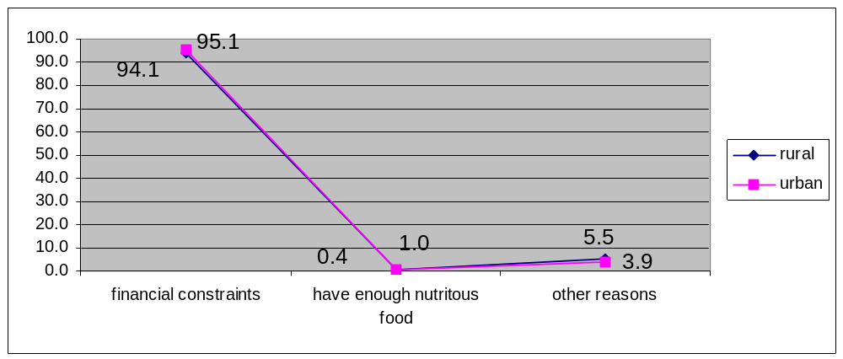

DISCUSSION

Consumers’ Knowledge about micronutrient malnutrition
Though micronutrient malnutrition is an immense public health problem in Malawi as indicated by the Malawi Micronutrient Survey (2001), over a third of both the urban and rural populations still do not know the problems that come due to inadequate intake of micronutrients. Worse still, higher proportions of those that are knowledgeable of the problem have low knowledge (83.9%-rural and 79.4%- urban). Consumers knowledge of the problems of micronutrient malnutrition and their consequences on health and socio-economic welfare of an individual, a family and the entire nation is very critical to the promotion of the benefits of food fortification and fortified foods and the need for drastic behavior change.

Consumers’ Knowledge about fortification
Behavior change starts with knowledge of the ‘important’ good behavior. In order for consumers to develop a perception of value of food fortification and to start spending more money on fortified foods, knowledge about food fortification, its purpose and benefits is crucial. Consumers need to understand what food fortification is all about, and how it can help to improve their health status. But according to the results, significant proportions of the populations, over 50% in the rural area and over 40% in the urban area do not know food fortification. Out of those that know food fortification, not more than 20% in both rural and urban areas have high knowledge about fortification. According to the results, the education level of respondents did not affect their level of knowledge about fortification. For instance, 100% of respondents who “had never attended school” in the urban areas had high knowledge about fortification while only 28.6% of those that had attained “college or university” education had high knowledge about fortification. In the urban area, more men (26.2%) than women (14.4) had high knowledge about fortification.

The understanding of consumers, about the purpose of fortification, was also very poor. Approximately 1 in every 10 people in both rural and urban areas had a better understanding of the purpose of fortification, which is “improving health through increased micronutrient content of fortified products and consequently increased micronutrient intake.” The majority of consumers either does not know fortification (56.7-rural and 41.9%-urban) or understand fortification just as a way of improving product quality (32.4%-rural and 45.9%-urban).

Consumer’s knowledge about fortified foods
It is now over a decade since fortified foods (such as iodised salt) started to be promoted on the Malawian market, according to the history of fortification in Malawi. However, at least 42.2% in the rural areas and 34.0% in the urban are not able to mention any one fortified product on the market. For instance, these consumers do not know that iodized salt is a fortified product and that it is very important to their health. Consumers’ knowledge about fortified foods and the micronutrients added to them is critical for them to make an informed choice on the market. Consumers should have the knowledge of which products are fortified, what they are fortified with and the importance of consuming the fortified products. Only

5.3 Attitude towards fortification
Attitude towards food fortification was assessed among consumers who had knowledge about fortification. Only 12.6% in rural areas and 7.0% in the urban areas had a negative attitude towards importance of fortification to the elimination of micronutrient malnutrition. 11.8% in rural areas and 17.7% in urban areas feel that fortification is not very important, as it cannot eliminate malnutrition among the poor. Their arguments center on the fact that fortified products are expensive and the poor Malawian community would not afford to buy them due to lack of financial power. This is one barrier to the promotion of food fortification. During the promotion of fortified foods, much emphasis needs to be put on the cost effectiveness of food fortification in terms of the health and economic benefits of micronutrient sufficiency.

5.4 Attitude towards choosing fortified foods
According to the survey results, high proportions of both rural and urban populations have positive attitude towards choosing fortified foods on the market. Approximately 90% of both urban and rural populations would choose fortified foods on the market other than their non-fortified substitute. But still a good proportion for both rural and urban populations, 9.5%-rural and 10%-urban, have negative attitude towards fortified foods for the following misconceptions:

- They feel fortification would cause diseases.
- Fortification is for child spacing and not for reducing micronutrient malnutrition
- Natural foods are better than fortified foods
- They have enough foods in their homes

5.5 Behavior of consumers
From a list of fortified foods currently available on the market, consumers were asked to mention the ones they consume in their households. Although the proportion of consumers who have a positive attitude towards choosing fortified foods on the market is very high, i.e. approximately 90% in both rural and urban areas, the proportion of consumers who do not consume any one fortified food is high especially in the rural areas. 32.6% in the rural areas and 19.7% in the urban areas do not buy any one fortified food. Approximately 90% of these consumers do not buy fortified foods because they claim that fortified foods are expensive for them. These figures need to be reduced through communication and education so that consumers understand and appreciate the benefits of fortified foods against the slight increase in price of a fortified product compared to the non-fortified counterpart.

Although a higher proportion of both rural and urban consumers are prepared to buy fortified foods in future, a significant proportion of both rural (25.9%) and urban (19.4%) populations are not prepared mainly due to lack of financial power.

Barriers to promotion of fortified foods
Promotion of fortified food is hindered more by the economic state of the country as opposed to cultural beliefs or ethics. According to the results, over 90% of the consumers are willing to choose fortified products on the market instead of the non-fortified substitutes. However, 32.6% in rural areas and 19.7% in urban areas do not buy the fortified products mainly because of lack of the buying power.

Although the situation is like this, communication and education is very important in order to change the mindset of the rest of the consumers who would not buy fortified products due to several reasons such as the fear that fortification is for child spacing and not for reducing micronutrient malnutrition.

Best ways of communicating the concept of food fortification
Most of the consumers, reported to have heard about food fortification from the radio (48.1%-rural and 55.0%-urban). This could be the best way of communicating the concept of food fortification and its benefits to all groups of people both in the rural and urban areas. However there is need to complement this communication channel with other types of communication channels so as to reach all people. In the rural areas, another important communication channel is the hospital or through health workers while in the urban areas, television would be another good communication channel.

RECOMMENDATIONS
Basing on the findings of this study, the following recommendations are made:
- In order to create a perception of value of food fortification among consumers there is a great need for communication and education in both rural and urban areas on the following important topics: micronutrient malnutrition and the situation among Malawians; health and economic consequences of micronutrient malnutrition; and food fortification and its benefits over other interventions
- Communication and education messages should aim at allying fears highlighted by the results of this survey such as: the fear that fortification might cause diseases and that child spacing drugs might be added to fortified foods
- Specific characteristics of fortified foods need to be aggressively marketed in this programme as follows: the fortified products; the added micronutrients; the vital roles of the micronutrient in the body; the consequences of inadequate intake of the specific micronutrients
- The reason for the slightly higher price of fortified foods and the cost effectiveness of buying fortified foods against the health and economic consequences of not consuming enough micronutrients foods should be communicated to consumers
- The grave socio-economic status of most consumers in Malawi is the greatest enemy to the promotion of this programme among consumers. As such the government of Malawi should put in place sound economic policies that would help to reduce poverty among Malawians and improve their buying power on the market. This would not only help the promotion of fortified foods but also all other programmes aimed at providing basic needs to consumers such as: food, health, education, water, sanitation and shelter.

APPENDIX 1: Acronyms and Abbreviations

CAMA Consumers Association of Malawi
CDC Centre for Disease Control and Prevention
GAIN Globe Alliance for Improved Nutrition
MBC Malawi Broadcasting Corporation
MFFP Malawi Food Fortification programme
MMS Malawi Micronutrient Survey
MICAH Micronutrient and Health
NFA National Fortification Alliance
NGO Non- Governmental Organisation
NMC National Micronutrient Committee
NSO National Statistics Office
TVM Television Malawi
UNICEF United Nations Children Fund
WFP World Food programme
WVI World Vision International

APPENDIX 2: References

- Malawi National Fortification Alliance; Malawi Fortification Initiative; 2004

- Ministry of Health; National Statistical Office; United Nations Children’s Fund; Centres for Disease Control and Prevention; Report of the Malawi Micronutrient Survey, May 2003.

- Ministry of Health, National Plan of Action for The Prevention and Control of Micronutrient Malnutrition in Malawi for 2003 – 2008, 2003

- www.nso.malawi.net

- www.micronutrient.org

